 SCHOOL *of* BUSINESS AND TECHNOLOGY

Department of Engineering and Aviation Sciences

**Smart Delivery**

**Kevin Harper**

**Eli Nbede**

**Montraz Oliver**

Advisor: Dr. Zhang

April 7, 2020

Design of Autonomous Food Delivery Vehicle

By

Kevin Harper, Eli Nbede, and Montraz Oliver

Submitted to the Department of Engineering and Aviation Sciences in partial fulfillment of the requirements for the degree of Bachelor of Science in Engineering at the UNIVERSITY OF MARYLAND EASTERN SHORE

Date

The author hereby grants the University of Maryland Eastern Shore permission to reproduce and distribute publicly, paper and or electronic copies of this document in whole or in parts.

Authors Kevin Harper, Eli Nbede, and Montraz Oliver

Signature

Date

Department of Engineering and Aviation Sciences

Certified by

**Introduction**

Autonomous self-driving vehicles are growing exponentially in popularity within new age technology. There are only a few level 5 self-driving vehicles that requires no human activation to drive. These self-driving cars are being used to transport goods and people around the world. Furthermore the electric car is preferred more often because it offer economic, global, and environment benefits. The car that we plan to design will deliver food to people autonomously.

**Background**

On the campus of the University of Maryland Eastern Shore there are many students that worry about their next meal and how they are going to get hold of it. A college student has numerous of responsibilities on their table that limits their ability to obtain in a necessary time. In most colleges’ freshman are not allowed to have cars and people with cars must pay a lot of money for parking and fees. This limit the amount of college students with cars and increases the amount of college students walking around campus. The gruesome schedule of college students makes it hard for them to eat food when its offered.

At the University of Maryland Eastern shore students are offered food at the locations including Students Service Center, Engineering & Aviation Sciences Complex, Hawk’s Nest, Waters Hall. In the Students Service Center they offer students plateau dining, and oasis staff dining. Often students argue and complain about the food they receive from the cafeteria. This leads them to eat the chic-fila food the university provides.

When college students are in their dorm after a long day of classes and stressful lecturing. They still must do homework and study for their classes. At that point they are tired of walking and going to get some food that is at least .4 miles away. Furthermore, during the school year there are not always clear and sunny days. Especially at UMES in the winter the weather can get rough. This will disable students from going outside and getting the food they need to satisfy their stomach.

“Among the 214 National Universities that reported these data to U.S. News in an

annual survey, the average percentage of students who brought cars to campus in the

2016-2017 academic year was 46.8 percent”.

**CHAPTER 1. INTRODUCTION**

**Objective**

Design an autonomous electric car that can deliver dining services around campus universities

**Design Requirements**

1. Travel distance a total of 2 miles
2. Carry up to eight pounds of food
3. Will deliver one meal at a time
4. Open and close of food compartment
5. Navigation
6. Speed of 5-10 mph
7. Detect and drive on the sidewalk
8. Detect crosswalk
9. Detect Objects
10. Website Application
    1. Payment System
    2. Ordering System
    3. Food Tracking
    4. SMS

**Design Constraints**

1. Tires might not be able to withstand certain road conditions
2. Driving in rough weather conditions
3. System is incapable of going up stairs or ramps
4. Driving on roadways

**CHAPTER 2. PROJECT DESCRIPTION**

**System Description**

The core system of the electric car is the raspberry pi that is interfaced with the camera module, lidar sensor, and the Arduino. The driving parameters from the camera and lidar such as object detection and lane detection is sent to the Arduino. The Arduino uses the parameters from the raspberry pi to control the car. Also the Gps is interfaced with the Arduino to send and receive location parameters from the website location. The arduino uses those gps commands to drive the car to the designated location. Arduino will notify the website when a designated location is achieved through telemetry, so it can then send an SMS to the recipient.

**System Diagram**

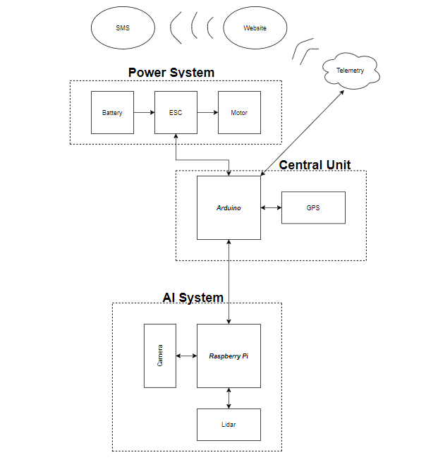

**CHAPTER 3. IMPLEMENTATION PLAN**

**Tasks**

Task1: Vehicle Structural Design

Subtask 1.1: CAD of structure

Subtask 1.2: Construct chassis

Task 2: Design Electrical Power System

Subtask 2.1: Identify electrical components

Subtask 2.2: Connect Components

Subtask 2.3: ESC Programming on Arduino

Task 3: Website Design

Subtask 3.1: Create Ordering System

Subtask 3.2: Design Payment System

Subtask 3.3: Design Food Tracking System

Subtask 3.4: Design SMS

Task 4: Design Artificial Intelligence System

Subtask 4.1: Design Neural Network

Subtask 4.2: Neural Network on Raspberry Pi

Subtask 4.4: Arduino - Raspberry Pi Communication: Serial Protocol

Task 5: Navigation

Subtask 5.1: Extract Geographic Coordinate Units

Subtask 5.2: Program GPS on Arduino

Task 6: Design RC Telemetry System

Subtask 6.1: ESC Telemetry

Subtask 6.2: GPS Telemetry

Task 7: System Testing, evaluation, and enhancement

Subtask 7.1: Test Design Requirements

Subtask 7.2: Evaluate and apply changes if necessary

Subtask 7.3: Repeat process

**Team Organization**

*3.2.1* ***Responsibility of Kevin Harper***

Task 1, Task 2, Subtask 5.1, Subtask 5.2, Subtask 4.1 and 4.4, and Task 7

*3.2.2* ***Responsibility of Montraz Oliver***

Task 1, Task 4, Subtask 5.1, Subtask 5.2, Task 6, and Task 7

*3.3.3* ***Responsibility of Eli Nbede***

Task 1, Task 3, Subtask 5.3, Subtask 5.4,Task 6, and Task 7

**Timeline/Milestone/Delivery Plan**

|  |  |  |  |  |
| --- | --- | --- | --- | --- |
| Time | Tasks | | | Comments |
| Montraz Oliver | Eli Nbede | Kevin Harper |
| Week 1 | Subtask 4.1 & 4.4 | Task 3 Subtask 1.1 | Subtask 2.1-2.3 |  |
| Week 2 | Subtask 4.1 & 4.4 | Task 3, Subtask 1.1 | Subtask 2.1-2.3 |  |
| Week 3 | Subtask 4.1 & 4.4 | Task 3, Subtask 1.1 | Subtask 2.1-2.3 |  |
| Week 4 | Subtask 4.1 & 4.4 | Task 3, Subtask 1.1 | Subtask 2.1-2.3 |  |
| Week 5 | Subtask 4.1, 4.2, 4.4, 5.1 | Task 3, Subtask 1.1, 5.3 | Subtask 2.1-2.3, 5.1 |  |
| Week 6 | Subtask 1.2, 4.2, 4.3, 4.5 | Task 3, subtask 1.2 , 6.1 | Subtask 1.3, 2.4, |  |
| Week 7 | Subtask 4.2, 4.3, 4.5 | Task 3 subtask 5.4 | Subtask 1.2, 1.3 |  |
| Week 8 | Subtask 4.3,4.5 | Subtask 5.4, 6.2 | Subask 5.4, 4.5 |  |
| Week 9 | Subtask 4.3, 4.5, 6.2 | Subtask 5.4, 6.2 | Subtask, 5.4 6.2 |  |
| Week 10 | Subtask 4.3 4.5 | Task 3, 6.2, 5.4 | Subtask 5.5 |  |
| Week 11 |  |  |  |  |
| Week 12 |  |  |  |  |
| Week 13 |  |  |  |  |
| Week 14 |  |  |  |  |
| Week 15 |  |  |  |  |
| Week 16 |  |  |  |  |
| Week 17 |  |  |  |  |
| Week 18 |  |  |  |  |
| Week 19 |  |  |  |  |
| Week 20 |  |  |  |  |
| Week 21 |  |  |  |  |
| Week 22 |  |  |  |  |